Name: _________Tuheena Singh____________

Lab #3: Classification II (updates in Green)

**Introduction:**

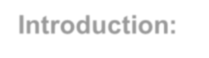

In this lab, we will go through standard classifiers and explore different test options available. You will encounter many situations in Data Mining problems where you need to choose an appropriate algorithm/ model suitable for data. In this lab, you will study some well-known classification algorithms and try to find out suitable models for your dataset.

Before starting the lab, make sure you are familiar with the Weka environment and the necessary procedures, such as loading the data and data preparation, etc.

Submit **a scanned copy of answered this Lab #3** to the Lab #3 DropBox by Sunday, 10/4 @11:59PM.

**Background reading**: <http://bit.ly/2ykAUFj>

**Note** Record classification accuracy in the table provided on page 4 (Table A).

# Part I. Partitioning Datasets for Training and Testing



**Dataset used:** ***diabetes*** dataset (Check data folder under Weka installation)

***C*ross-Validation:**

In this model validation method, the dataset is divided into k subsets (these are called “folds” and k< number of instances). It performs k number of iterations with k-1 subsets as training set and the remaining one as the test set. All the iterations are averaged, which can be seen in the Weka output window after performing this task.

* Follow steps performed to load data to Weka from Lab 2 (Note: Use *diabetes* dataset)

* Navigate to the classify tab, then choose the J48 classifier and select cross-validation with ten folds with all other default options.

* Click on Start and observe the results on the right pane.

* Similarly, perform the 10-fold Cross-validation for NaiveBayes (in Bayes folder) and jRip (in rules folder).

* Record classification accuracy in **Table A** (page 4).

**Percentage Split:**

In this test method, the data is split into two parts. First, n% of the dataset is reserved for training data to build the model and the remaining (100-n)% as test data.

Follow the steps performed in Lab2 to load data and perform analysis using three different classification algorithms:

* NaiveBayes (in Bayes folder)
* J48 (in trees folder)

•

jRip

(

in rules

)



For each algorithm, use two test options:

* Training set

|  |
| --- |
| • |

The percentage split ~~66%~~ 75%

Record classification accuracies in **Table A** (page 4).



**Sample o**

**utput**

**from a W**

**eka classification model**

**:**

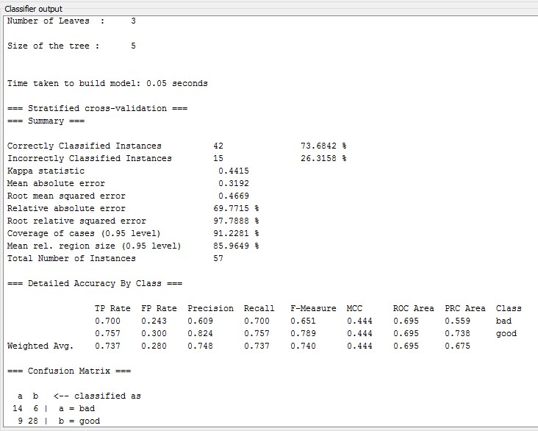

Classification

accuracy

Confusion

Matrix

The essential numbers that you should focus here are:

Correctly classified Instances, Incorrectly Classified Instances, and the confusion matrix.

Write down classification accuracy (in percent; rounded to the nearest integer) obtained in the table below:

**Table A**

|  |  |  |  |
| --- | --- | --- | --- |
| **Test Options** | **Training set** | **Percentage Split 75%** | **10-fold crossvalidation** |
| J48 | 84.1% | 77.1% | 73.9% |
| NaiveBayes | 76.3% | 78.1% | 76.3% |
| jRip | 79.3% | 78.1% | 76% |

|  |  |
| --- | --- |
| Q1.1 | Compare using training set and percentage split approaches. Did the accuracy increase? Comment on the changes.  Overall, Training Set(TS) approach has performed better than Percentage Split(PS) method. However if seen closely Incase of Naïve Bayes, PS has performed better than TS approach. J48 sees considerable difference between the two approaches. It is also well known that TS approach is a biased approach. Accuracy is always higher with Training set method as we are training the classifier on the same set we are testing on. |
| Q1.2 | Based on the results obtained, which classifier will be best for this dataset? Support your answer.  Based on the results, Naïve Bayes approach will be better than the other two as NB is performing better in case of Percentage Split and 10 fold cross validation method. JRip can be considered as one of the alternative approaches as it is parallel to the NaiveBayes approach. However 10-fold cross validation approach has better results in case of NaiveBayes. |
| Q1.3 | What is the significance of the number of folds 10 in cross-validation?  The number of folds signify, the number of groups of equal size the dataset would be split into. When we are doing 10 fold cross validation we split the data into 10 groups every time we build a model using 9 data splits and test on the remaining 1 set. That’s how we test our algorithm 10 times on a different test dataset. This gives an estimate on how our algorithm will perform if tested on an unseen dataset. |
| Q1.4 | Assume a dataset consists of 36instances, what is the size of test data used for: |
| 1. 9-fold cross validation - 4 (9 x 4=36)      1. 75% percentage split - 9 (75% of 36=27; 36-27=9) | |

# Part 2. Nearest-Neighbor Classifiers

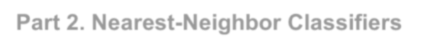

**Datasets used:** ***breast-cancer*** & ***glass*** (Check data folder under Weka installation)

Open the ***breast-cancer*** dataset and click the Classify tab.

|  |  |
| --- | --- |
| Q2.1 | Select a lazy classifier, IBK. What is its accuracy in percent evaluated using 10-fold cross-validation? |
|  | 72.377 ~ 72.4% |
| Q2.2 | IBK’s KNN parameter specifies the number of nearest neighbors to use when classifying a test instance, and the majority vote determines the outcome. The default value is 1. Evaluate KNN’s performance with 2, 3, and 5 nearest neighbors. What accuracies do you get in percent? |
|  | K=2: ___73.42%__ K=3: __73.77%__ K=5: __73.42%__ |
| Q2.3 | Do you think these accuracy differences (Q2.2) are significant? Support your answer by running IBK with the default value of 1 for KNN using random number seeds: 1,2,3,4,5 recording the accuracies: (Click the “More options …” in Test options to enter a random seed) |
|  | Seed #1: __72.37%__ Seed #2: _73.77%_ Seed #3: _70.97%_ Seed #4: __73.77%__ Seed #5: __72.37%__ |

Are the differences significant? Yes/No

No, the accuracy differences are not significant. The range of the accuracies are 2.8 and the mean is 72.65 %.

Q2.4 One of the issues with IBK is how to choose a suitable value for the number of nearest neighbors. If it is too small, the method is susceptible to noise in the data. If it’s too large, it covers a too great area of instance space.

Let’s simulate by adding noise artificially to the ***glass*** dataset to determine the nearest neighbor's optimal value.

* Open the ***glass*** dataset.
* Select the unsupervised attribute filter ***addNoise*** (see Figure 1 below).
* Observe from its configuration panel that it adds 10% noise to the *last* attribute by default, which is the class. You will change this value to add 20 & 30% to test and ***Apply*** the filter (see Figure 2 below).
* Now run the IBK to find the optimal number of neighbors as you add noise. When you run IBK with added noise, change ***crossValidate*** to True, and 20 is a safe value

to use for KNN in these experiments (Figure 3). Don’t forget to ***Undo*** the effect of the ***addNoise*** filter after each experiment.

* What is the best number of neighbors for each? You can find it in the “Classified model” section of the output.

Noise 0%: _1_ 10%: _4_ 20%: _4__ 30%: _12_

Figure 1

Figure 2

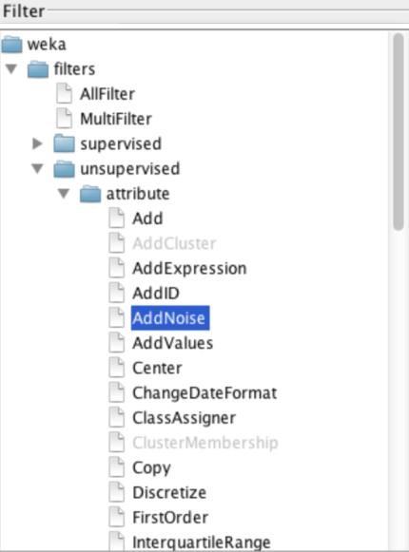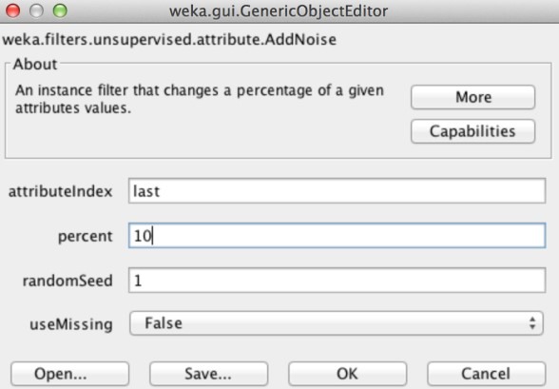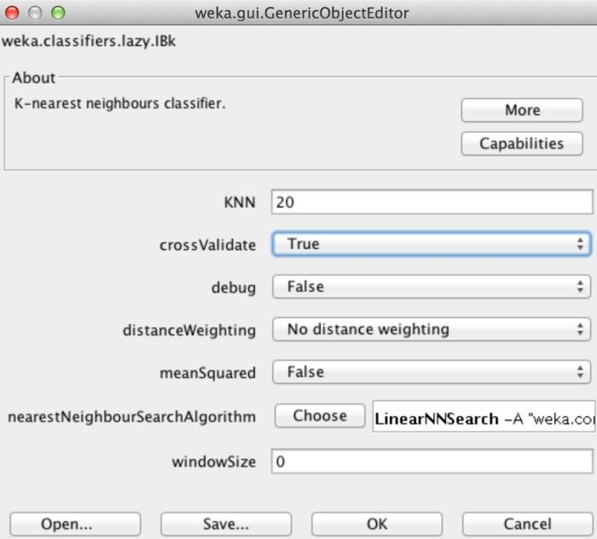

Figure 3

# Part 3. Naïve Bayes Approach

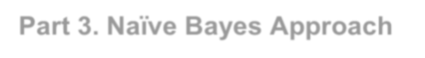

Consider the dataset shown in Table B.

Table B

|  |  |  |  |  |
| --- | --- | --- | --- | --- |
| Record | A | B | C | Class |
| 1 | 0 | 0 | 0 | Y |
| 2 | 0 | 0 | 1 | N |
| 3 | 0 | 1 | 1 | N |
| 4 | 0 | 1 | 1 | N |
| 5 | 0 | 0 | 1 | Y |
| 6 | 1 | 0 | 1 | Y |
| 7 | 1 | 0 | 1 | N |
| 8 | 1 | 0 | 1 | N |
| 9 | 1 | 1 | 1 | Y |
| 10 | 1 | 1 | 0 | Y |

Q3.1 Estimate the conditional probabilities below. Apply the Laplacian smoothing if applicable

(show all calculations)

|  |  |  |  |  |  |
| --- | --- | --- | --- | --- | --- |
| P(A|Y): | P(A=1|Y)= 3/5 :4/7 |  |  |  | P(A=0|Y)=2/5  3/7 |
|  |  |  |  |  |  |
|  | P(B=1|Y)= 2/5 : 3/7 |  |  |  | P(B=0|Y)=3/5 |
|  |  |  |  |  | :4/7 |
| P(C|Y): | P(C=1|Y)= 3/5 | Using Laplace:  P(C=1|Y)=4/7 |  |  | P(C=0|Y)=2/5 |
|  |  |  |  |  | Using Laplace: 3/7 |
|  |  |  |  |  |  |
| P(A|N): | P(A=1|N)= 2/5 : 3/7 |  |  |  | P(A=0|N)=3/5 |
|  |  |  |  |  |  |
|  |  |  |  |  | :4/7 |
| P(B|N): | P(B=1|N)= 2/5 : 3/7 |  |  |  | P(B=0|N)=3/5 |
|  |  |  |  |  | 4/7 |
| P(C|N): | P(C=1|N)= 5/5 Using Laplace: 6/7 |  |  |  | P(C=0|N)=0/5 |
|  |  |  |  | Using Laplace: |  |

=0+1/5+1*2 =1/7

Q3.2 Use the Estimate of conditional probabilities given in the previous question (Q3.1) to predict the class label for a test sample (A = 0, B = 1, C = 0) using the Naïve Bayes approach. (Show all calculations)

P(Y | (A=0,B=1,C=0)) = __________P(A=0|Y) * P(B=1|Y)* P(C=0|Y) * P(Y))____________

P(A=0|Y) * P(B=1|Y)* P(C=0|Y) + P(A=0|N) * P(B=1|N)* P(C=0|N)

= ___3/7 * 3/7 * 3/7 * 0.5__

(3/7* 3/7 * 3/7 ) + (4/7 * 3/7 *1/7)

=0.03936 / 0.1137

=0.3462

P(N | (A=0,B=1,C=0)) = __________P(A=0|N) * P(B=1|N)* P(C=0|N) * P(N))____________

P(A=0|Y) * P(B=1|Y)* P(C=0|Y) + P(A=0|N) * P(B=1|N)* P(C=0|N)

=(4/7 * 3/7 *1/7*0.5) / ((3/7* 3/7 * 3/7 ) + (4/7 * 3/7 *1/7)) =0.1538

As P(Y | (A=0,B=1,C=0)) > P(N | (A=0,B=1,C=0)) , the class label for the sample is Y.

ISTE-600 LAB 3 Gradesheet Name: __________________________

Graded By: __________________________

|  |  |  |  |
| --- | --- | --- | --- |
| Questions | Max. Points | Points Earned | Comments |
| Part 1 |  |  |  |
| Table A | 10 |  |  |
| Q1.1 | 5 |  |  |
| Q1.2 | 5 |  |  |
| Q1.3 | 10 |  |  |
| Q1.4 | 5 |  |  |
| Part 2 |  |  |  |
| Q2.1 | 10 |  |  |
| Q2.2 | 10 |  |  |
| Q2.3 | 10 |  |  |
| Q2.4 | 15 |  |  |
| Part 3 |  |  |  |
| Q3.1 | 10 |  |  |
| Q3.2 | 10 |  |  |
| TOTAL | 100 |  |  |